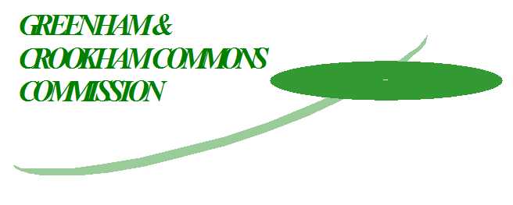

**Greenham & Crookham Commons Commission Meeting**

**Tuesday 15th October 2024: 7pm**

**Meeting to be held at Greenham Common Control Tower**

|  |  |
| --- | --- |
| **Commissioners** | Sue Ellis (WBHF & Chairman), Ken Neal (Commoner and Vice Chairman), Chris Austin (Commoner), Judith Curson (Commoner), Derek Cutt (Commoner), Nicole Rorie (Commoner), Frank Huxtable (Commoner), Claudia Sievers (Commoner)  Tony Ferguson (Greenham Trust), Julian Swift-Hook (GPC), Roger Hunneman (NTC), Simon Pike (TTC), Billy Drummond (WBDC), Erik Pattenden (WBDC), Laurence Parker (GCCV), Tony Vickers (LAF), |
| **WBDC Appointed Officer**  **Secretary** | Paul Hendry (WBDC)  Kim Lloyd (Greenham Parish Council Clerk/Responsible Finance Officer) |
| **Advisors** | Tom Hayward (BBOWT), Roger Stace (BBOWT), |

**Agenda**

1. Apologies
2. Declarations of Interest
3. Public Session
4. Adder Bites in Dogs on the Commons
5. Minutes of the last meeting 23rd July 2024 and Matters Arising

**Matters for Decision and presentation**

1. Governance and other Committee roles
2. Cattle on the Commons – decision on future numbers 2025
3. Greenham & Crookham Commons Regulations – informing and enforcing – letter to Commoners
4. Greenham 25th Anniversary 2025 Forward planning

**Additional papers and reports**

1. Committee reports –
2. AOB
3. Date of the next meeting.